User Manual: System Help

| july-20 |

**Document Overview**

**Documentation Goals**

This documentation is intended to provide instruction for ***Using the Help Information throughout the Advantzware Software System****.*

**Table of Contents**

**Help on Any Browser** 2

**Help for Any Field Definitions** 3

# **Help on Any Browser**

On any program screen system throughout the Advantzware Software, the user can look up any available system information pertaining to the current program. This allows the user to read select manual information without having to open the User Manual for the selected system.

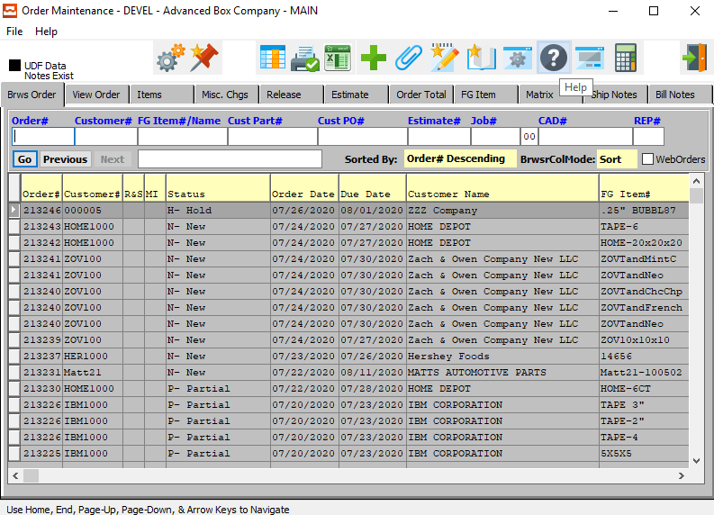

For help on any browser screen throughout the system, the user can click on the ***“Circled Question Mark Icon”*** button at the top of the screen.



This will bring up the *Help Information* screen for the user. If the current system has any information available for the user, it will be detailed here.

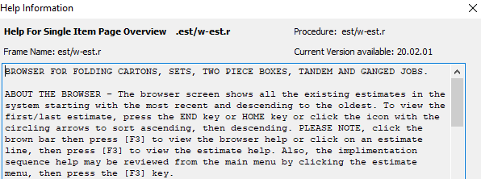

# **Help for Any Field Definitions**

If the user finds that they need help with a specific informational field within the system, they can search for any available help information for individual fields.

To do this, the user must first make sure that their cursor is located in the field that they wish to look up information for. In the below example, please note that the cursor is located in the *Customer Part #* field.

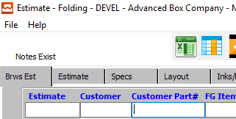

For help on a specific field, the user may press the ***“F3”*** key in order to bring up the *Help Information* screen for the user. If the current field has any information available for the user, it will be detailed here.

